What stage am I at?

Introduction to this workbook
Seeing the career planning process and learning what stage you're at can help you:
- Feel more confident, knowing what to focus on next
- Feel more motivated, breaking things up into smaller, more do-able steps
- Make informed decisions
This workbook helps you pick an exercise from the careers help toolkit that fits the stage you're at now.

Step 1: Learn about the DOTS model
The DOTS model turns thinking about your next career choice into a nice neat diagram. It can be useful to see it as a flowchart, a ‘how to’ guide which walks you through how to ‘do careers’:
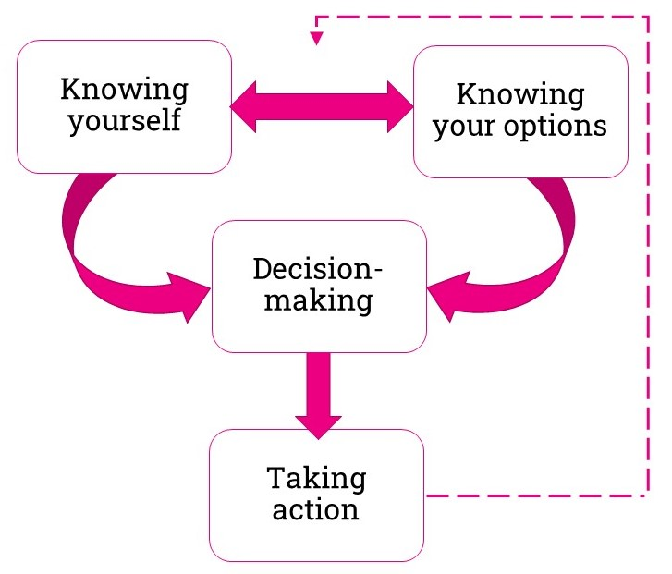
It was first created by Bill Law and A.G. Watts in 1977, although it’s been adapted and revised over the years.
We’ve revised it a bit too to reflect our experience in careers advice. We reworded some of the boxes, and added in the two-way arrow and the dotted arrow.
It's called ‘DOTS’, even though the letters don’t come in that order. In the order of the model it's Self - Options - Decision-making - Taking action. That gives the SODT model, which isn't that catchy (not without an 'i' anyway).

To understand the DOTS model better, let’s look at each part in turn
Part | Description
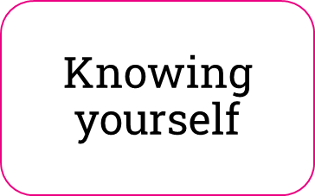 | Knowing what your skills, values and interests are right now.  Knowing what’s important to you and some of the ideal ‘ingredients’ for a good option.
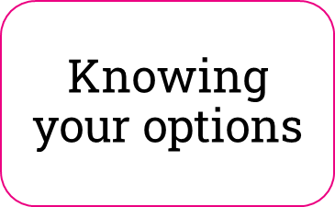 | Knowing the main categories of options available to you  (e.g. apprenticeships, courses, jobs, self-employment).  Researching options that you're interested in, or that fit your skills or values.
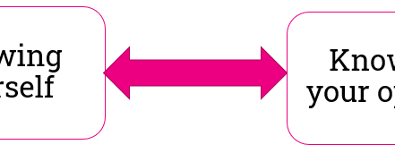 | By researching options you can find out more about yourself and vice versa. What ideas are you most and least enthusiastic about? What does this tell you about what the ideal 'ingredients' for a good option are?  By learning about yourself you can learn which options to explore in more detail. What's are the most important things for you? Start looking at options related to what you're looking for.
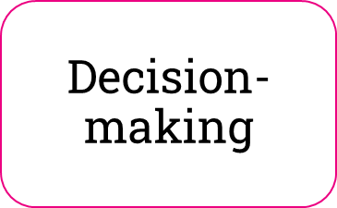 | Narrowing down your options to a manageable shortlist  Choosing which option or options to go for.  You could then set a goal for what you want to achieve.
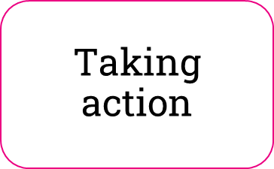 | Doing something about it!  Making a plan of action that breaks things down into managable steps.
Learning from the action you take.
Learning more about yourself and your options by reflecting on what you do.
Career planning is a process of lifelong learning.

Why is the DOTS model useful?
Knowing there’s a process you can follow can make decision-making feel easier.
It can also help you avoid common issues, like:
- Feeling overwhelmed by having to make a decision. This is sometimes a problem when ‘decision making’ comes first in the process.
- Applying for things that don't suit your skills, values or interests. This can be a problem when ‘taking action’ comes first in the process and can waste time and energy.
- Struggling to narrow down your options. This can be an issue if the 'knowing yourself' stage is missing and you have too few criteria to assess your options.
- Taking action but finding the option is nothing like what you thought. This can be a problem if the 'knowing your options' stage is missing and you didn’t have enough information.

Step 2: Take the quiz
You might already be able to spot what stage in the DOTS process you’re at, but if not, our quick quiz might help:

Question 1: How would you summarise your situation?
Pick one option that best describes you.
Options | Tick (one row only) | Letter
I know what kind of thing might suit me, but I don't yet know real options like it that are available | ☐ | B
I know about some of the options available to me, but I'm not sure what would suit me best | ☐ | A
I've found different options look like they might suit me equally well | ☐ | C
I've made a decision... but I haven't done anything about it yet | ☐ | D
I don’t know where to start | ☐ | A and B

Question 2: What do you know so far?
Pick one option that best describes you.
Answer options | Tick (one row only) | Letter
I know how to find options and rate how well they suit me to find a good choice | ☐ | D
I mainly know about my skills, what I'm interested in and what's important to me | ☐ | A
I mainly know about options that are open to me at the moment | ☐ | B
I don't really think I know much that would be useful in making choices yet | ☐ | A and B
I know some options that would suit my skills, interests and what's important to me | ☐ | C

Question 3: What other statements describe you?
Pick all that as apply
Answer options | Tick (all that apply) | Letter
I’m not sure I know what I’m looking for in a good option | ☐ | A
I’ve decided what I want, but I’m not sure if what I’m doing towards it is right | ☐ | D
I don’t think I have enough information about my options | ☐ | B
I’ve made a choice, but don’t know what to do now | ☐ | D
I’ve made a decision but now I’m procrastinating | ☐ | D
It’s pretty random which options I have information about right now | ☐ | B
I couldn’t tell you what I’m really interested in | ☐ | A
I’m not sure what I’m good at | ☐ | A
What I know about my options is largely through what I’ve heard other people saying | ☐ | B
I could decide what to do next easily, if it weren’t for some unknown factors | ☐ | C
I know what I want, but not how to get there | ☐ | D
I’ve got a shortlist of options, but it’s hard to choose between them | ☐ | C
I only really know about options where I know someone who’s done it | ☐ | B
I’m not sure what’s important to me | ☐ | A
I’m not feeling good about narrowing down my options | ☐ | C
I’m not sure how to narrow down my options | ☐ | C

Results
Count how many ticks you have for each letter. Your highest scoring suggests the stage you’re likely at in the DOTS process:
Letter | Count ticks for this letter | DOTS category
A |  | Knowing yourself
B |  | Knowing your options
C |  | Decision-making
D |  | Taking action

Step 3: Pick an exercise to try
Pick an exercise to try from our Career help toolkit online for your highest scoring stage. If there’s more than one scoring highest, choose the stage that comes first in the DOTS model.

If you’re at the ‘knowing yourself’ stage
Pick an exercise from the Career help toolkit sections labelled ‘I want to…’
- Understand what my skills are
- Understand what my values are
- Understand what my interests are

If you’re at the ‘knowing your options’ stage
Pick an exercise from the Career help toolkit sections labelled ‘I want to…’
- Find career ideas using quizzes
- Find career ideas linked to my favourite subject
- Find the facts about my career ideas
- Find out about people's experiences of different careers
- Find more about different courses and qualifications
- Find out more about apprenticeships and school leaver jobs

If you’re at the ‘decision-making’ stage
Pick an exercise from the Career help toolkit sections labelled ‘I want to…’
- Decide what I'm going to do next

If you’re at the ‘taking action stage
Pick an exercise from the Career help toolkit sections labelled ‘I want to…’
- Take the next step towards my career idea

Step 4: What did you learn?
Which exercise did you choose to do?

What did you learn from the exercise you tried?

What are you going to do now? All of these are good options:
☐ | Do more of the course, but use the Career help toolkit again as I move through the stages
☐ | Do another exercise or two for the stage I’m at now, then do more of the course
☐ | Read the descriptions of the other course workbooks and prioritise what’s most relevant to me right now

Law, B. & Watts, A. G. (1977). Schools, Careers and Community: A study of some approaches to careers education in schools. London, UK: Church Information Office (pp. 8-10).

